Solutions & Solubility
What is a solution?

A solution is a homogeneous mixture of two or more pure substances, which may be solids, liquids, gases or a combination of these and composed of only one phase. A homogeneous mixture is a physical combination in which particles of one or more substances (solute) are distributed uniformly throughout another substance (solvent) at the molecular or ionic level. Generally, in a solution the percentage of solvent is more than 50 percent.

Types of solution

- Depending on the three physical states- gas, liquid and solid; (nine types)

  - Gas in gas; Example- air
  - Gas in liquid; Example- soda water
  - Gas in solid; Example- H₂ gas absorbed by heated palladium
  - Liquid in gas; Example- water vapor in air
  - Liquid in liquid; Example- alcohol in water
  - Liquid in solid; Example- mercury in gold (mercury amalgum)
  - Solid in gas; Example- camphor (C₁₀H₁₆O, white crystalline) in air
  - Solid in liquid; Example- sugar solution
  - Solid in solid; Example- Ni-Cu alloy (monel metal)

- Depending on the temperature; (two types)

  - Exothermic solution: The process of dissolution of a solute in solvent involving evolution of heat energy due to breaking and formation of bonds. Examples: CaO or NaOH or strong acids in H₂O etc.
  - Endothermic solution: The process of dissolution of a solute in solvent involving absorption of heat energy due to breaking and formation of bonds. Examples: NH₄NO₃ or glucose in H₂O, evaporation of H₂O etc.

- Depending on the equilibrium; (three types)

  - A saturated solution is a solution containing the maximum concentration of a solute under certain temperature and pressure. Additional solute will not dissolve in a saturated solution and simply settle down as undissolved solids.

A solution in which dissolved solute and undissolved solute are in equilibrium.
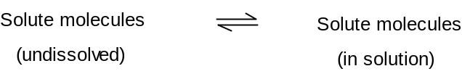
There exists a dynamic equilibrium between the undissolved solute molecules and the solute molecules in saturated solution.

  - A supersaturated solution is a solution containing more solute than a saturated solution. The solubility of a solution increases as the temperature or pressure is increased. This means that as the temperature rises, more solute can be dissolved. Increased pressure also increases maximum possible saturation and allows for a supersaturated solution.
  - An unsaturated solution is a solution containing less solute than a saturated solution. An unsaturated solution has room for additional solute to be added and fully dissolved, without settling and sedimentation occurring.

Properties Solvents

What is Solvents?

The vast majority of chemical reactions are performed in solution. The solvent fulfills several functions during a chemical reaction. It solvates the reactants and reagents so that they dissolve. Generally a good solvent should meet the following criteria.
- It should be inert to the reaction conditions.
- It should dissolve the reactants and reagents.
- It should have an appropriate boiling point.
- It should be easily removed at the end of the reaction.
Non-polar reactants will dissolve in non-polar solvents. Polar reactants will dissolve in polar solvents. For our purposes there are three measures of the polarity of a solvent: (a) Dipole moment, (b) Dielectric constant, (c) Miscibility with water.
- Dipole moment: It occurs due to equal amount of positive and negative charge separated by a distance within a molecule. Mathematically, μ = q × r; where μ = dipole moment (unit is Debye, D), q = charge of atom in coulomb and r = distance between charges in Å. Knowledge of dipole moment is useful to know the extent of polar character and geometrical shape of a molecule.
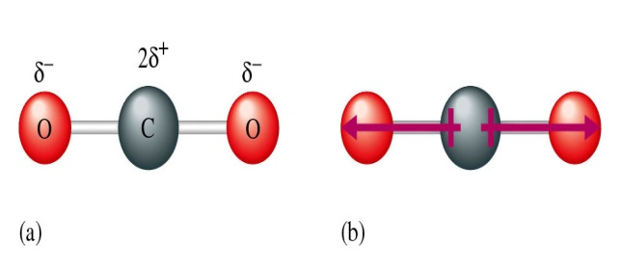
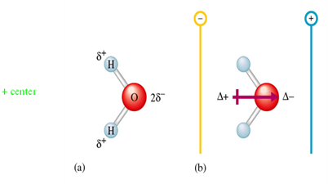

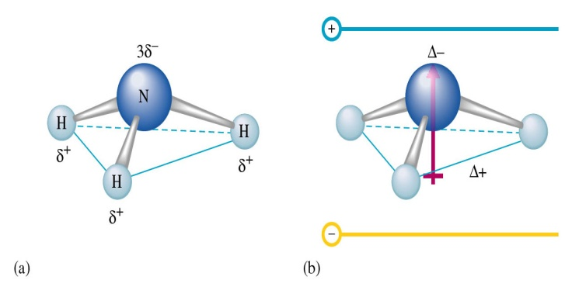

Figure: Dipole moment of (a) H₂O, (b) CO₂ and (c) NH₃
- Dielectric constant: The dielectric constant of a solvent may be defined as its capacity to weaken the force of attraction between the electrical charges in that solvent. It is a measure of the polarity of the solvent. Mathematically, F = e²/rD; where D = dielectric constant, e = charge, F = force of attraction and r = distance between charges.
Molecules with large dipole moments and high dielectric constants are considered polar. Those with low dipole moments and small dielectric constants are classified as non-polar. On an operational basis, solvents that are miscible with water are polar, while those that are not are non-polar.
Solubility
The amount of a substance that dissolves in a given quantity of solvent at a given temperature to form a saturated solution is called its solubility.
Factors Affecting Solubility
- Nature of the solute and solvent
  - Ionic and polar substances dissolve in polar solvent, e.g. NaCl in H₂O
  - Nonpolar substances are dissolved in nonpolar solvents, e.g. Napthalene, oil etc. in C₆H₆, CCl₄.
‘Like dissolves like’ - that means substances dissolve in chemically similar solvents.
- Effect of temperature
A higher temperature increases both the rate of dissolution and also the solubility of the solute.
- Rate of solution
  - At a low temperature the rate of solution is quite low. At higher temperature dissolution of more solute causes.
  - The rate of dissolution may be increased by shaking or stirring of the solvent-solute mixture.
  - Particle size factor: The process of solution being a surface phenomenon, the greater the surface of contact between the solvent and the solute, the higher will be rate of solution.

Mechanism of dissolution: How do the evolution and the absorption of heat arises?
To explain this, we have to analyze the process of dissolution of a solute in a solvent. For example, the dissolution of common salt, NaCl in H₂O.
The process involves the following sequences:
- H₂O molecules attack the Na⁺ particles and detach these from crystal lattice against the attractive force of the adjoining particles i.e. the Cl⁻ ions.
- The solvent particles may require to be pulled apart to make room for Na⁺ particles.
- The Na⁺ particles are solvated (the interaction of ions of a solute with molecules of solvent) by the solvent molecules.
Energy is required for operations (a) and (b) while as a result of operation (c) energy is liberated.
When the energy requirement for the operations (a) and (b) is greater than that released from operation (c), the temperature of the system goes down i.e. heat is absorbed during the dissolution of NaCl molecule. The amount of heat absorbed is called positive heat of solution (endothermic system).
When the energy requirement for the operations (a) and (b) is less than that released from operation (c), the temperature of the system goes up i.e. heat is evolved during the dissolution of NaCl molecule. The amount of heat evolved is called negative heat of solution (exothermic system).
Problem-1: Calculation of normality of strong acids,
(a) 36% (w/w) HCl, specific gravity 1.18 and
(b) 96% (w/w) H₂SO₄, specific gravity 1.84

Gas Laws

The gas laws are a set of laws that describe the relationship between temperature (T), pressure (P) and volume (V) of gases.

Boyle’s law (1662, Relation between volume and pressure of gas):

Boyle's Law states that the product of the volume and pressure of a fixed quantity of an ideal gas is constant, given constant temperature. Expressed mathematically, the formula for Boyle's law is:
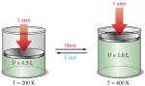

where:
V is volume of the gas.
P is the pressure of the gas.
k is a constant

Charles law (1787, relating volume and temperature):

Charles's law states that at constant pressure, the volume of a given mass of a gas increases or decreases by the same factor as its temperature (in Kelvin's) increases or decreases.

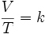
The formula for the law is:

where:
V is the volume.
T is the temperature (measured in Kelvin's).
k is a constant.

Gay-Lussac's law (1809, relating pressure and temperature):

The pressure of a fixed amount of gas at fixed volume is directly proportional to its temperature in kelvins. i.e. P/T = K

These three laws were combined to form the combined gas law
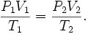

Ideal Gas Law
With the addition of Avogadro's law, this gave way to the ideal gas law-
,

i.e. “The state of an amount of gas is determined by its pressure, volume, and temperature”

where, P is the pressure (SI unit: Pascal)
V is the volume (SI unit: cubic meter)
n is the number of moles of gas
R is the ideal gas constant (SI: 8.3145 J/(mol K))
T is the temperature (SI unit: Kelvin).

The ideal gas law is the most accurate for monoatomic gases at high temperatures and low pressures. Because at lower pressure the molecular size becomes less important for larger volumes and intermolecular attractions diminishes with increasing temperatures.

Ideal gases
Ideal gas is a hypothetical gas that obeys the gas laws exactly. An ideal gas would consist of molecules that occupy negligible space and have negligible forces between them.

Avogadro’s law (1811)
Equal volumes of all gases contain equal numbers of molecules (Avogadro’s no., 6.023× 10²³) at the same pressure and temperature. The law, often called Avogadro’s hypothesis, is true only for ideal gases.

S.T.P.- Standard temperature and pressure (or formerly known as N.T.P.- normal temperature and pressure) are used when comparing the properties of gases. They are 273 K (or 0⁰C) and 101 Pa (or 760 mmHg).

